RECOLLECTIONS of SUPER STORM SANDY

By Rob Youngs
310 W 4th Street

As we sat in our home at 310 W 4th Street in South Bethany on an October day of 2012, reviewing the forecast for Hurricane Sandy coming up the east coast, Kathy and I debated the wisdom of riding out the storm, or leaving for a safer place. We discussed options and there seemed to be three. One was that the storm would turn left and go up the Chesapeake, which in my opinion would be the worst scenario, putting us on the northeast quadrant of a massive storm. Not a good place to be. The second was that it would be a repeat of Irene from August 2012, since that storm had continued up the coast and not turned left the shifting winds blew the water from the canals before it could reach a depth to flood dwellings. Not too bad an option and it kept us away from the deadly northeast quadrant. The third was for the storm to turn left at or north of us, and since Hurricanes tend to like to follow water routes, we figured north of us at the Delaware River was where it would turn if it did, perhaps not a bad option at that. (Didn’t necessarily turn out that way.)

n preparation, we had put all of our outdoor furniture away, or secured it firmly. We did not want any flying hazards when the winds came, which they would no matter the path the storm took. Flooding is always a potential when you live in a flood zone, but no damaging flooding had occurred in the nearly thirty years we had known South Bethany, so the probability seemed remote. The 100 year flood level was 18 inches above our ground floor, but surely it would never make that mark.

As it became apparent that the storm would continue north, to our east, and since Kathy was Mayor of South Bethany and the Town Manager was out of town, we decided it would not be unsafe to remain and ride out the storm.

Kathy was busy with town strategies to deal with the coming storm, and warning those who were still in residence to either leave or be prepared, I was left to prepare the house for the onslaught. As the storm came up the coast, the water level came up as expected.

Continued on next page……
We visited the beach to see what it looked like. It appeared that once again we would be spared the brunt of the storms fury.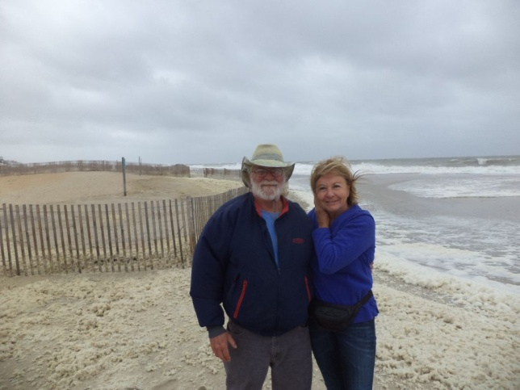

Preparations continued, water rose, and the mayor was busy looking after the town and its residents. I was taking pictures of the flooding, so reminiscent of Irene the year before.

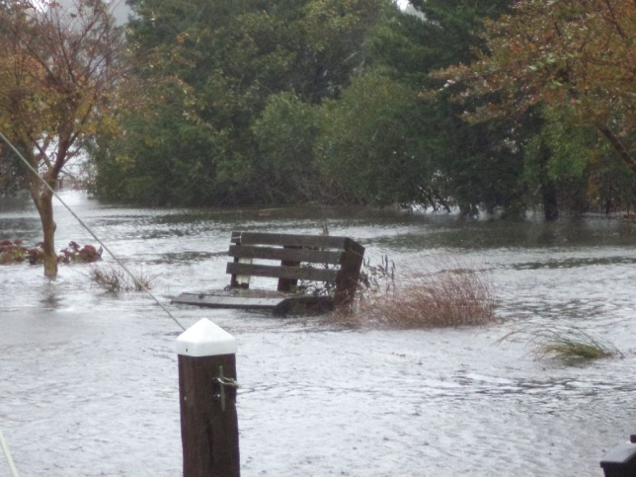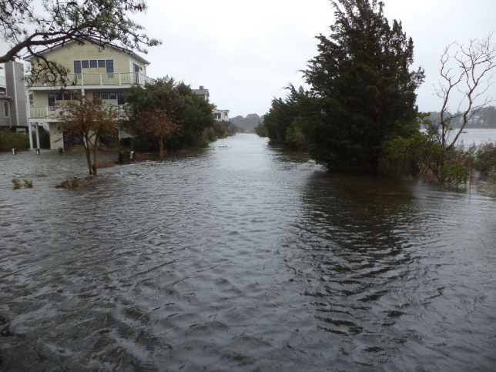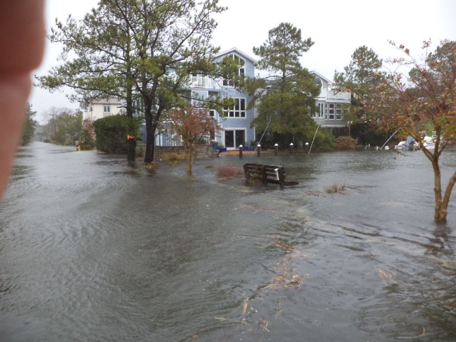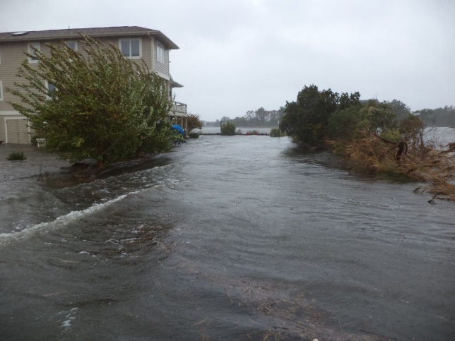

As the storm passed, it seemed the wind had not been too bad, things had stayed put pretty well, and all seemed to be going according to the way it should.

The storm eventually turned left, missed the Delaware Bay, but hit New Jersey pretty hard as it tried to make the turn. Now a tropical storm, no longer a hurricane, all should have been good. However, since the storm made a left turn just to our north, we never got the assistance of the shifting winds to blow the water back out of the canal, instead, it continued to blow water into the canals.

As we watched the water rise past the end of the canal and across the street, not the first time for that, happens frequently from Nor’easters, we were watching the bench at the end of the canal, the one we had so lovingly planted with mostly native plants to make it look better, we wondered how they would survive the brackish water. Spring would tell us how well we selected plants for that location.

A bench at the canal end was the measuring rod I was using. As long as the water stayed below the seat of the bench, our deck would remain above water. As darkness fell, the water was still rising and we could no longer see the bench seat.

I drove through the flooded streets to retrieve Kathy from the town hall. We came back down canal, through maybe two feet of water getting deeper all the time, and went to pick up a neighbor on Second Street to spend the night at our house since we had lost power, and did not want her to stay alone. On the drive back up canal, going to find a high spot for the two dogs we had with us, my headlights seemed to stop short and not light up the road. Strange, worked well before. As we approached Ninth Street, we saw that a tree had fallen across Canal Street in the short time we had been at the other end. Kathy of course called the town maintenance and told them of the tree. (They removed it almost immediately.) We did find a dry spot on Eighth Street for the dogs, by the way.

As the night progressed, so did the water level. We were now getting water into our ground level, how much higher would it go, the wind showed no signs of shifting in our favor.

In the morning, we found the water had risen 18 inches inside our house. Hmm, right at the 100 year flood level. Kathy went back to the town hall, neighbor went home, and I started sweeping water as soon as the wind let it start to subside. Oh, and of course I went wading to take some pictures. I like the one with white caps on Canal Street.

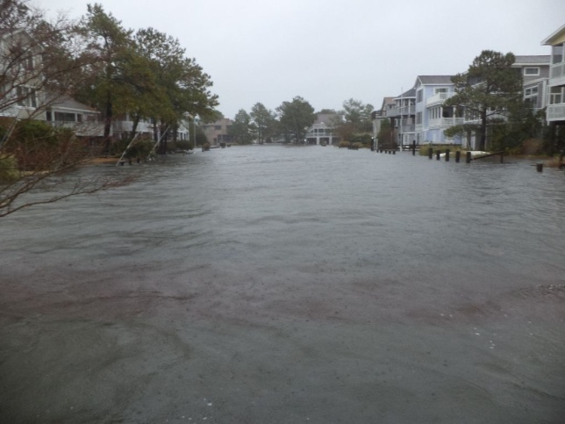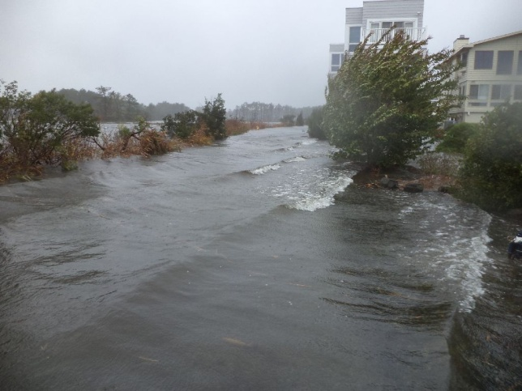
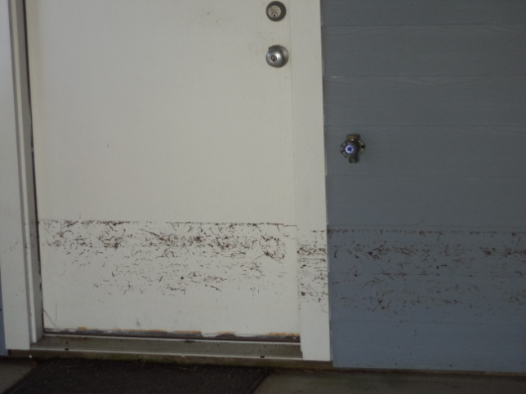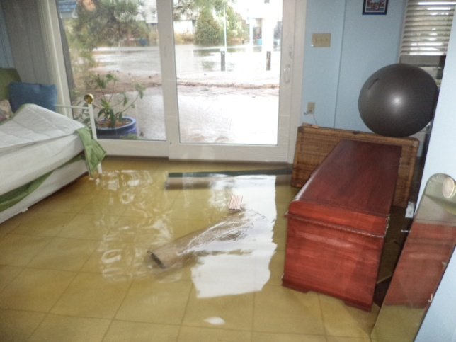

We, along with most of our neighbors on the bay side of South Bethany suffered significant damage to our home. Upwards from $75,000, this included Kathy’s car, my motorcycle, and most items that were on the first floor of the house. You can see from the picture above the water level on the outside of the door to the ground level.

At one point during the night I dad walked out onto out canal side deck, and was surprised to find it not underwater, then I realized it was bouncing as I walked on it. It was floating, if only it had gone back done from whence it rose, but alas, that was not the case.
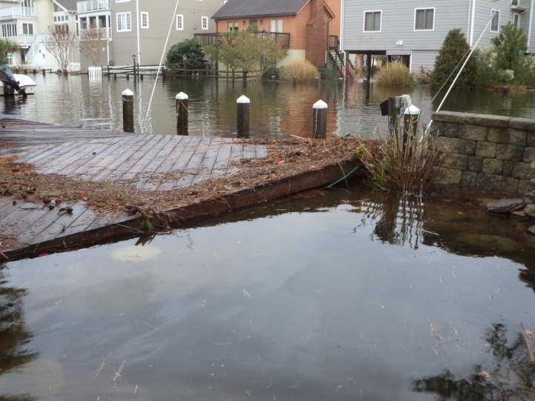

The wind damage was minimal, the flooding extensive, but the water went down as it always does and we set about to let the clean up begin. It will take well into next spring before all is put back into place.

