The Callaway Flood Saga…Hurricane Sandy Hits South Bethany 240 Bayshore Drive, South Bethany, DE
October 2012

News reports of the approaching storm were constant…with Cable TV news and weather reports running 24/7, it was hard to avoid hearing minute by minute accounts of where Super Storm Sandy was, where it could be heading, and what scenarios would play out if the storm did this or that or if it took this route or that route! When the storm appeared to be eminent, we began the traditional storm preparations outside the home on Friday, October 26th – which included moving all the outdoor furniture, kayaks, etc. to safe places and assembling our hurricane bag. We realized our Carolina Skiff boat was in jeopardy – we did not have the trailer to move it out and
our normal go-to boat person was not reachable. So Robbie and I and our 88 year old neighbor Roland Maheaux – who was set to stay and ride out the storm – tied up the boat and covered it to prevent it from filling up with water. Roland’s Navy years helped us tie up the boat with super secure sailor knots! Pending reports of possible “doom” also initiated our family discussion of what to do if a mandatory evacuation was issued. Robbie firmly insisted on staying – to protect the house – and do everything he could do to minimize damage to “Sue’s beloved beach home.” Robbie very much wanted me to leave and head to our condo in Gambrills, Maryland. I knew what he meant – if things got as rough as it appeared they could get – he didn’t want to worry about me. As a Town Council Member, I had mixed feelings about staying and leaving – adhere to a mandatory evacuation notice or stay and do what I could to help save our home or help others. Anticipating the worst, I emailed our builder and let him know we would need him for damage repair and recovery should we need any – a decision that really paid off after the storm.
So when the mandatory evacuation was issued late on Saturday, October 27th, I reluctantly left
South Bethany on Sunday in our Toyota convertible – with my neighbor Carol Stevenson following in her car. She had secured her home and decided to leave as her husband had rushed to Seattle with a family emergency a few weeks earlier. Being alone at this time was not a comforting plan.
With me safely in Gambrills, thus began the watch and wait for Robbie and several others who elected to stay in South Bethany. Bayshore Drive had a few die-hard homeowners riding out the storm: across the street was our wonderful young neighbor Mike Tine who wanted to stay while his wife Karen returned to their home in Virginia and her job in DC; along with long-time resident Roland and another elderly (by age only as this man could outwork any younger person any time) neighbor Bob Hesaltine. No way was my husband going to leave these almost 90 year- old neighbors! Our other elderly neighbor Bea Nowell reluctantly left with her children who traveled from Dover to get her. Bea called frequently to supposedly check on storm conditions but we think she was just calling to make sure Robbie was okay! As reports became more foreboding, Robbie set to making further preparations – duct taping strong plastic sheeting
around the entryway doors, moving furniture onto the elevator and sending the elevator to the 3rd

floor for safety! Sunday moved forward and while winds picked up and rains came – it didn’t appear to be too much – yet! Thus the watch and wait continued.
Back at the condo in Maryland, Monday started out as a pretty normal day – until about 1:00 pm and then the really heavy rains came. Things were picking up in South Bethany as well. Constant weather reports tracking the storm spoke of great potential for major destruction and damage…watch and wait…during tornado warnings advisors said go to the lower level of your home – then during flood warnings advisors said go to the upper level of your home!! What to do?? Where is the safest place to be? As the rains increased, Robbie began to notice the driveway filling up with water – but was proudly impressed that his duct taped plastic was holding firm and no water was coming in the front door. Then suddenly, he noticed water coming in under the foyer steps…how did that happen? Then he heard a gurgling sound…and saw water seeping out from the elevator shaft. In what seemed like a matter of moments – things changed! Water was pouring into the foyer! Thinking he could stay on top of the flooding – Robbie grabbed a large drywall bucket and began baling out the water…running up several steps to our laundry room to dump out the water. This baling water and racing back and forth to the laundry room went on for hours. The amazing thing was that electricity and cable TV were still on and thus dooming forecasts were still being announced! Then Robbie realized he should turn off the circuit breakers – without thinking – he stood in 2 feet of water and turned off the electricity. One of those things that when you are so tired you just do and realize later what could have happened! As the night wore on – Robbie began to wear out, exhausted by the futile baling
– the battle with the water was clearly being won by Mother Nature! As he checked out the back door – he could see fish swimming on our patio and our weighted down storage container had been washed away. Our vegetable box garden – made of heavy duty railway ties – was moving and shifting. The boat was still hanging in there but rising by the moment – would the ropes stay tied? The water had now reached the top step to the back door. Robbie made one last phone call to me at the condo before he turned in for the night. I remember his words exactly, “Sue I have done everything I can think of to protect your beloved beach home – I have no idea what more I can do. It is now up to God and Mother Nature.” After saying goodnight and watching the ominous news reports one more time, I suddenly remembered that many of our important papers and bonds were stored on the first floor, under the stairs! I quickly called Robbie back and made one more request – remove those storage bins under the stairs as it is very likely they will be destroyed should the water come through the back door. Completely exhausted from his hours of baling water, he returned to the first floor to move all those storage bins.
After a restless 2 hours of sleep – Robbie awoke at daybreak. With his phone’s video camera rolling and capturing his fervent anticipation, he slowly made his way from the 3rd floor down to the first floor. He was certain he would find our first floor completely flooded. As he peered down, he cautiously observed “it’s dry, it’s dry, it’s DRY!!!” The water had not exceeded that final back door step and our main first floor had not been flooded – just the foyer entryway. The
relief was great. Robbie then opened the garage door from the foyer and found himself “dazed

and confused.” Everything was out of order and in the strangest places – the garage was completed flooded and everything was ruined. He then went back upstairs to the second level and peered out the front window. He noticed that the truck’s windows looked steamed up – he soon realized that the truck had been flooded completely. We would later learn that our Honda Ridgeline truck was totaled. Who ever imagined that such a thing could happen! The streets were completely flooded. The entire street looked like a river of sorts. No streets – no driveways – just water, water everywhere. Mike and Robbie were in constant communication and agreed to set out exploring. Mike had lost everything on his ground level first floor. They checked on Roland
– who was safe and secure and decided to kayak down Bayshore Drive. They made their way down Bayshore via kayak, and went up to the east side and see how the beaches and Oceanside homes had fared. It was amazing….in the scheme of things, very minor damage. Thank goodness our beloved beaches were in tact…the walkways and a few dunes were ruined.
They kayaked back and made their way home – to begin the task of sorting through the damage and assessing what had been done. By Tuesday afternoon late, fortunately the water had receded and Bayshore Drive was a road again! Just about everything in the garage was destroyed… Robbie quickly set up tables in the driveway and began sorting and drying things out. In the meantime, back at the condo and unable to return until the evacuation was lifted, I knew then that if we had that much damage – so did everyone else! South Bethany had quite a clean-up job on the horizon and the Town Council would need to act quickly. Mayor Kathy Jankowski had suffered substantial loss also…her home is adjacent to the wetlands and the flooding greatly impacted that area of our town. She and I talked on Wednesday – I knew that if we had that much trash that the town was going to have to figure out a way to help people clean-up their homes and the mess Super Storm Sandy had left behind. People were overwhelmed with debris and trash and mess…after an Emergency Town Council Meeting on Thursday – we had a plan to address the trash issue and a strategy for helping people get rid of things and attending to multiple tasks. By Thursday, Bayshore Drive looked like a war zone….neighbors were comparing stories and the common theme was – we are so fortunate no lives were lost and that we did not get hit as badly as the Jersey coast! What if the storm had not taken that last minute turn? Yes, South Bethany may have experienced the “flood of 100 years” but we were indeed lucky – we dodged a huge bullet!
We lost a truck and in addition we had over $50,000 worth of damage and loss of content. Nearly 2 feet of water had flooded our home. We learned a lot about flood insurance and about FEMA, and insurance adjustors, etc. But our house is still standing and repaired. But most importantly, everyone in our family and community was safe. Super Storm Sandy was another significant reminder of what really matters in life! And, the wonderful folks of South Bethany came together as a community and worked very hard to cleanup and repair. By Thanksgiving – when people arrived from New York and elsewhere their consistent comment was, “it doesn’t even look like anything happened!”

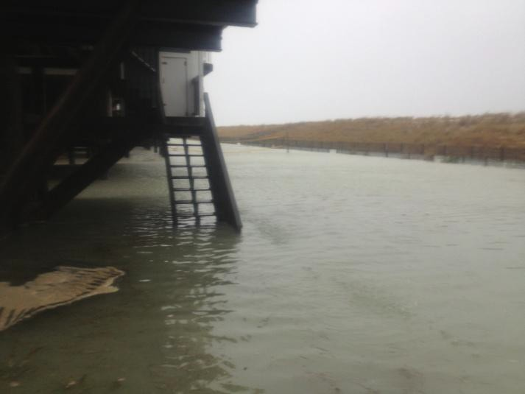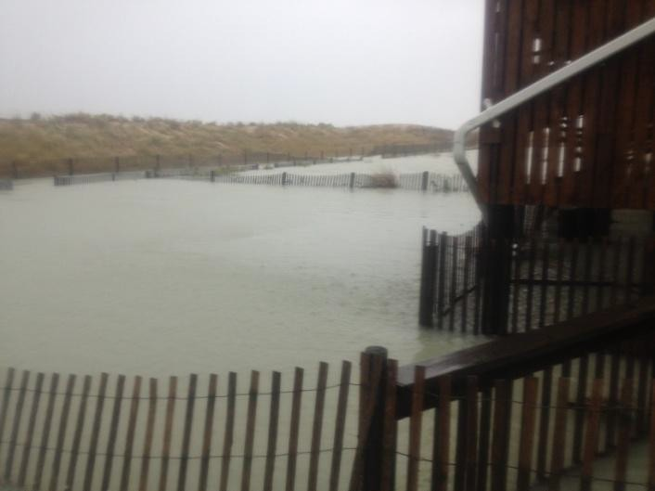Eastside Backyards After Storm Looking North Eastside After Storm Looking South

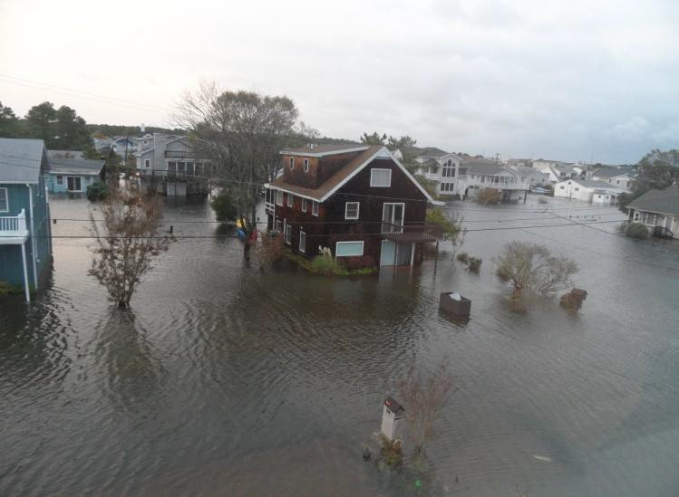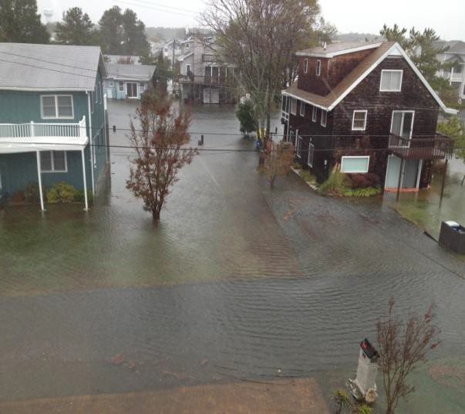

Bayshore Dr. Looking North During Storm Bayshore Dr. Looking North After Storm

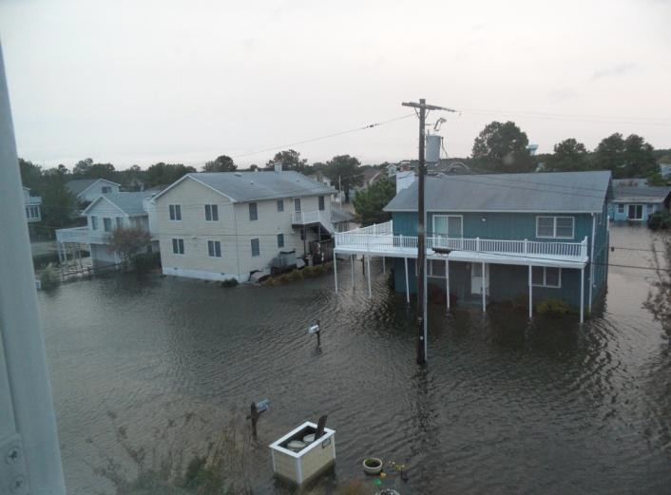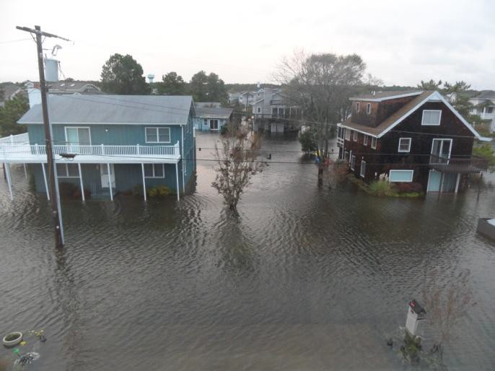

Bea Nowell's Bayshore Dr. House After Storm Nowell House and Bisson House on Bayshore Dr.

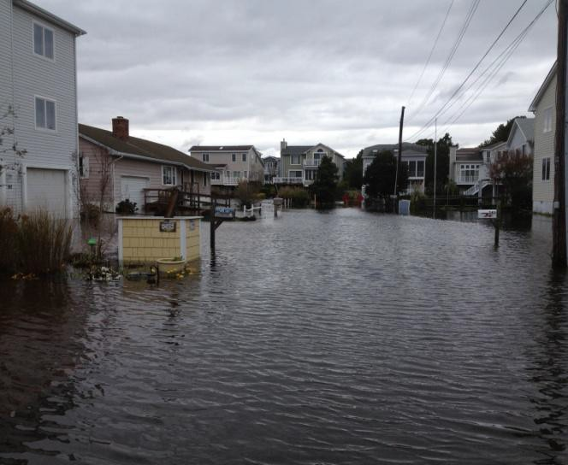

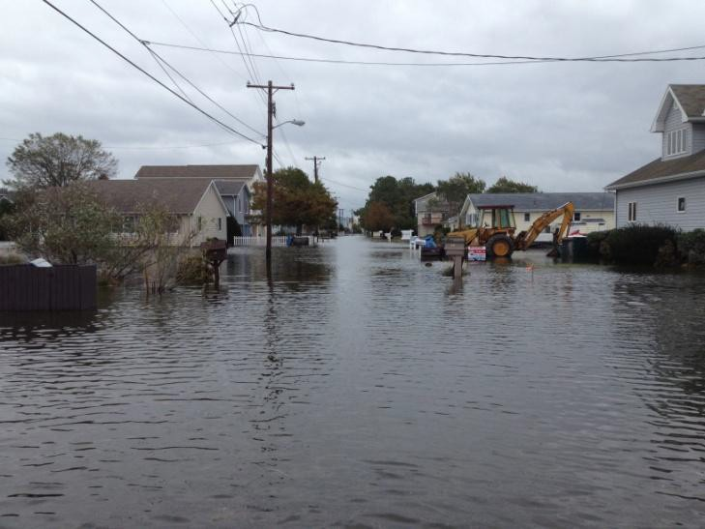Looking West on Bayshore Dr. After Storm Looking East on Bayshore Dr. After Storm

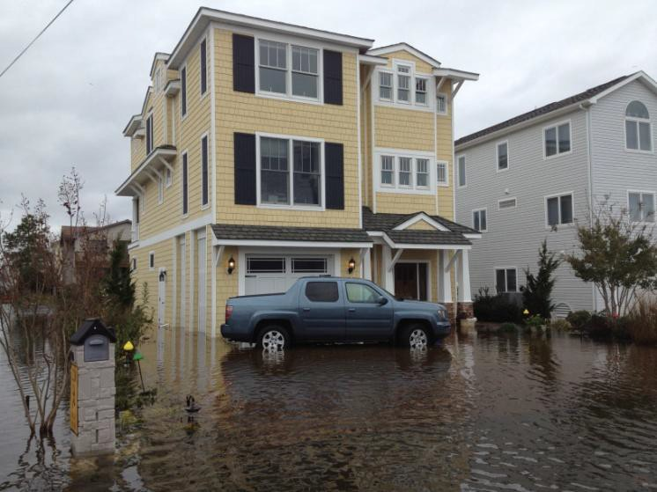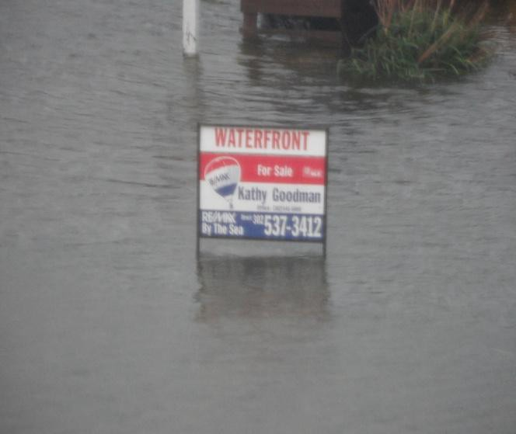

The Irony of this For Sale Sign is too funny! Callaway House After Storm – Truck Totaled

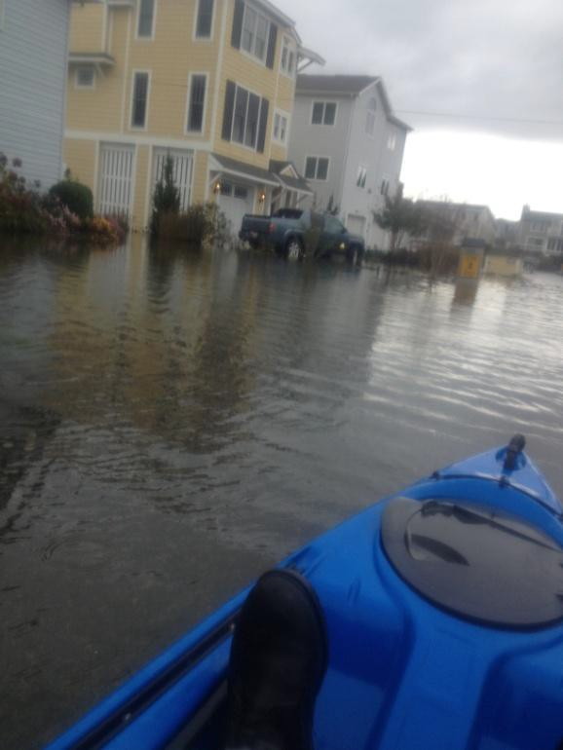

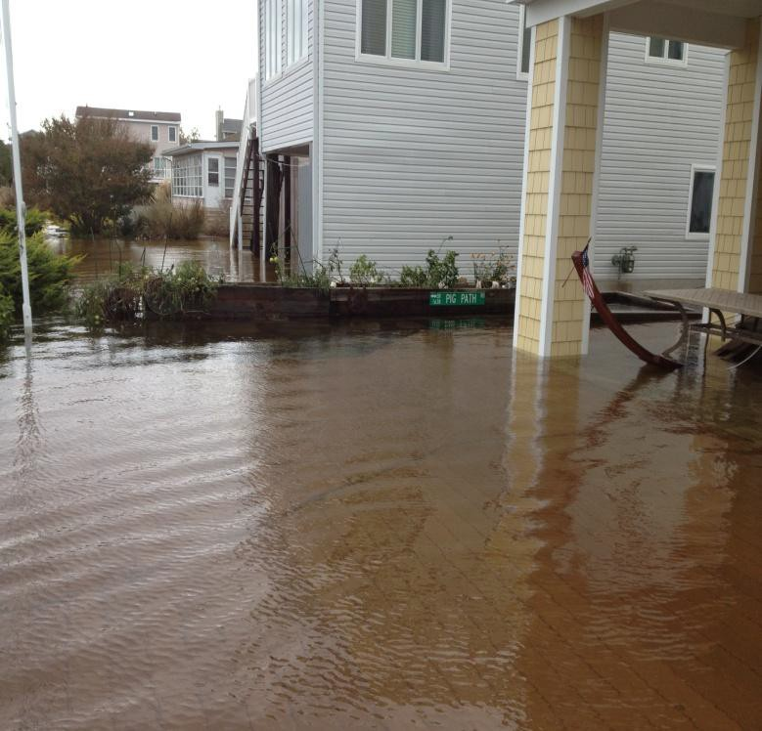Robbie Kayaking on Bayshore Dr. Behind Callaway House - Box Garden moved during storm

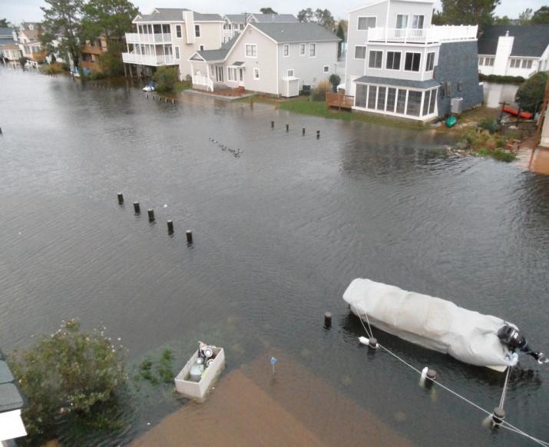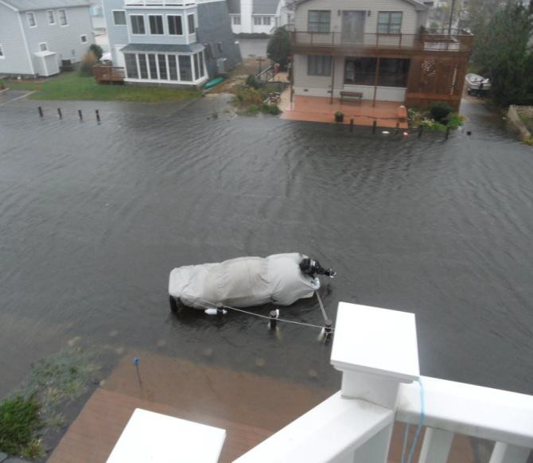

The Callaway Boat was Saved! Looking Southeast from back of Callaway House

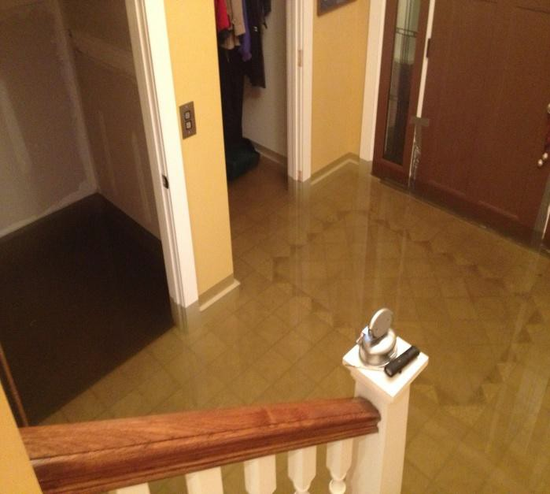

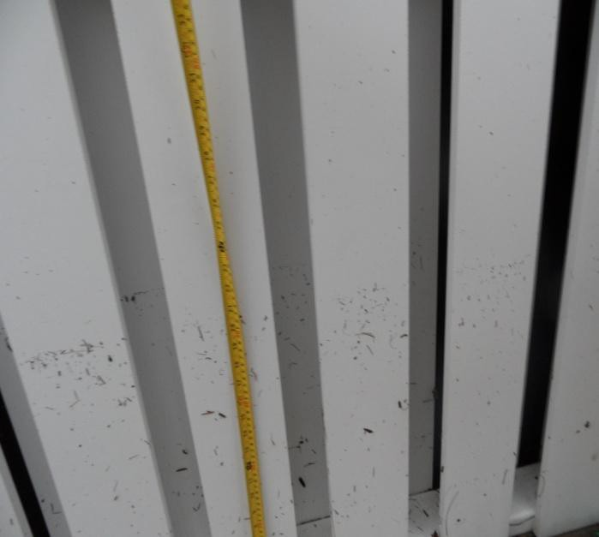Flooded Callaway Foyer Post storm Measurement

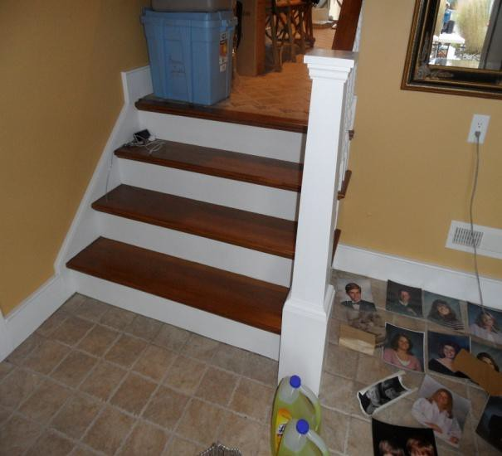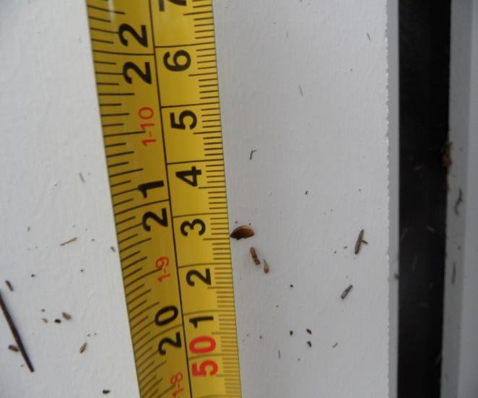

Water Height reached 21 inches Rescuing Precious Graduation Photos

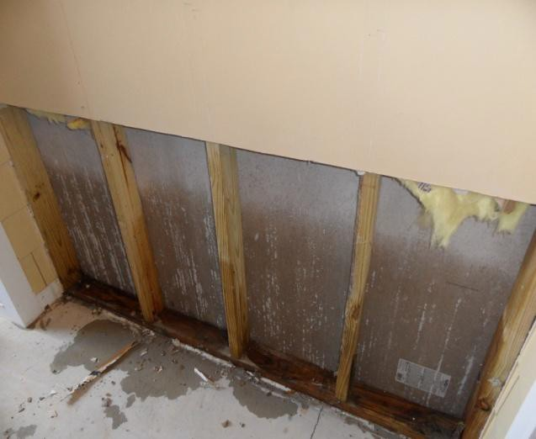

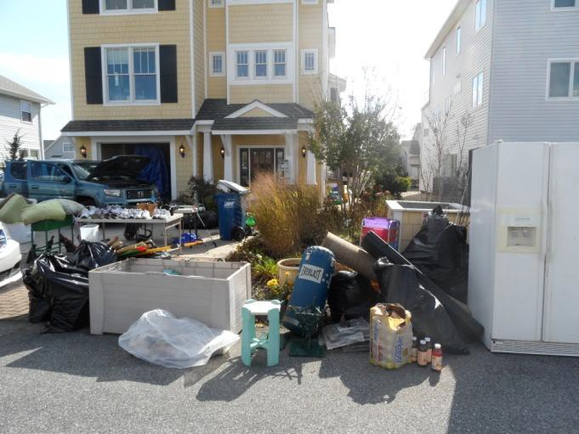Removing drywall and insulation Callaway Trash Pile - Just like every other house on Bayshore Dr.

