TABLE OF CONTENTS
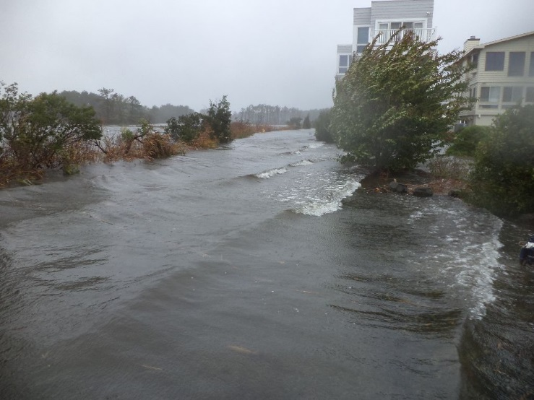  Superstorm Sandy October 2012  W. 1st Street and Canal | a Mayor’s viewpoint  This is a report of how I, as mayor of South Bethany, experienced and lived through Super Storm Sandy or as we came to know it Franken storm Sandy.  Kathy Jankowski  Mayor of the Town of South Bethany

Chapter 1 – Before the Storm 2
Friday, October 26, 2012 2
Saturday, October 27, 2012 2
Sunday, October 28, 2012 3
Monday, October 29, 2012 3
chapter 2 – during the storm 5
Tuesday, October 30, 2012 5
chapter 3 – after the storm 6
Wednesday, October 31, 2012 6
Thursday, November 1, 2012—TRASH, TRASH, TRASH 6
Friday, November 2, 2012—ANOTHER STORM HEADING OUR WAY 6
Saturday, November 3, 2012 7
Sunday, November 4, 2012 7
Monday, November 5, 2012 7
Tuesday, November 6, 2012 8
Wednesday, November 7, 2012 8
Thursday, November 8, 2012 8
Saturday, November 10, 2012 9
Wednesday, November 14, 2012 9
Thursday, November 15, 2012 9
Friday, November 16, 2012 10
chapter 4– moving on 11

BEFORE THE STORM

Friday, October 26, 2012
I knew, when I became mayor, that I would have some responsibility when South Bethany was hit by a storm. However, I was in no way aware of what would occur at the end of October 2012. On Friday, October 26, I participated in the first of many Sussex County Emergency Operations Center (EOC) telephone conference calls, where all key emergency personnel and all town municipalities in Sussex County came together to discuss preparations for Hurricane Sandy. It was expected to hit early Tuesday morning somewhere between Sandy Hook, NJ, and the Delmarva Peninsula.
The Town of South Bethany is very fortunate that the Maintenance Supervisor, Don Chrobot, and the Chief of Police, Joe Deloach, are both experienced and dedicated. With the Town Manager out of Town and unable to get back, I felt the Town of South Bethany was in my hands. After speaking with Don and Chief Joe, I was confident they were handling the preparations for the Town, so I turned my attention to our property owners. Pam Smith, Renee McDorman, and Dee Burbage were taking care of the offices.
Many of our home owners are gone for the season and news programs usually don’t cover the Bethany Beach area. Since one of my top priorities is communications, I wanted to start sending out news updates. I put myself in the property owners’ shoes to think about what they would want to know. My plan was to send a news update after each EOC telephone conference call at 10 am and 5 pm. Pam Smith, the Town Administrative Assistant, was my right hand person in emailing the communications. The first news update went out at 1:37 pm on Friday and basically advised people of the weather situation and how to personally prepare. At this point, I thought the brunt of the storm would hit the ocean side as was normal with most storms in the past. Residents east of Ocean Drive were advised that water, sewer, and gas could be shut off as early as Sunday night or Monday morning.
There was not much new to report with the second update at 5 pm, so I informed the oyster gardeners that now would be a good time to “winterize” their oysters. This would get the floats into storage.
Saturday, October 27, 2012
As of 8 pm on Saturday, October 27, there was a limited state of emergency for the State of Delaware. South Bethany was part of a mandatory evacuation to be completed by 8 pm Sunday night, October 28. Anyone within ¾ of a mile from the coast was required to evacuate. Shelters would be opening by noon the next day at Indian River High School, Cape Henlopen High School and Milford Middle School. All shelters were supposed to accept pets. I also sent a news update to property owners to inform them about the process followed by Delmarva Power should their electricity go out. I also asked them to secure items that might blow away for an absent neighbor.

Sunday, October 28, 2012
By Sunday at 1 pm, Route 1 was closed between Fred Hudson Road and Dewey Beach. I was so concerned about our dune because I was sure we were going to lose it. All I could think about was how many houses would be damaged or destroyed on Ocean Drive. The ocean was already to the base of the dunes.
Now we were getting a large number of telephone calls from neighbors asking us to secure items. Chief Joe had someone in Cat Hill who needed to be evacuated to Lewes and didn’t have any way of getting there. Without question, Rob Youngs volunteered to take her and her dog. Of course, he had to go the long way through Dagsboro since Route 1 was closed. Officer Patrick Wiley was prepared to spend the night at the Police Station with his sleeping bag!
I continued to send news releases after the morning and evening emergency conference calls. Pam was coordinating this from her home. I had to go to the Town Hall because we didn’t have any power at our house.
There was no power on W. 3rd and W. 4th Streets, so our neighbor, Lori Cicero, and her dog Isla, spent the night with us.
Monday, October 29, 2012
The storm was now set to make landfall between Cape May and Atlantic City tonight with winds shifting to the southwest by 3 to 4 am on Tuesday. This morning the ocean had breached the dunes at the south end of Ocean Drive near Kewanee. Some of the dune fence was already in the ocean. (I’m still believing the storm will hit the ocean side harder than the bay side.)
At 10:30 EDT the canal tide gage read 3.25 feet and rising. This was near low tide. The maximum that has been recorded at the gage is 3.52 feet. I believe we will exceed that before the storm is over. High tide in the bay will occur about 2 pm today. Surely, that will be the end of the rising waters! (So I thought and, therefore, did not move my car from my driveway!) Our neighbors moved their car to the parking lot at Town Hall. We discovered later that this was not far enough away from the rising water.
With the help of Don Chrobot, the Maintenance Supervisor, I started sending out updates of streets where the canal ends were flooded over bulkheads; i.e., W. 2nd, W. 3rd, York, Kimberly, Victoria, Bristol, Layton; and where street ends flooded over bulkheads; i.e., West Bayshore, Layton, Godwin, W. 2nd, W. 1st. There was no visible damage to properties at this time. Most major roads providing access to South Bethany were closed; i.e., Route One between South Bethany and Fenwick Island, Route One north of Bethany Beach, and Route 54. Route 26 had flooded at Vines Creek.
The Sussex County Emergency Operations Center Video Update #7 was sent out shortly after 3 pm. A message from Mediacom assuring residents they were working around the clock to restore services was sent out around 4:30 pm.
There was no power at our house, so we spent the night with our neighbor, Lori Cicero, who lives on W. 3rd Street. Water came pouring into the truck as we opened the door to go into her house. We estimated it to be at about 18 inches at this point. It was a very eerie feeling because there was no wind. The water was just slowly rising. With everything out of our control, we went to bed for the night. I’m still worried that the storm is going to hit the ocean side of South Bethany. It has been taking some very strange turns during its course up the coastline.

DURING THE STORM

Tuesday, October 30, 2012
I awoke about 4 am to the smell of baking cookies, only to find my neighbor, Lori Cicero, baking Halloween cookies in her kitchen. It seems that Lori bakes whenever she is restless and can’t sleep. When I came into the kitchen, she was decorating ghosts with white icing and pumpkins with orange sprinkles! Anyway, it was time to “face the music” and see what had occurred during the night in our Town.
As I walked out of the house, our neighbor Frank Duchesne said “Mayor, I think you can declare the drought is officially over!” Somehow, that little bit of humor went a long way for me that day!
Rob and I drove up to Ocean Drive. The south end of the dune didn’t appear to have sustained any further damage after yesterday’s erosion. Basically, Ocean Drive and Sand Piper Village didn’t even look like we had a “super storm.” The west side of South Bethany was another story! Almost all ground was covered in water. All bulkheads had been breached. We estimated about 18 inches of water at our house on W. 4th Street.
Of course, all travel was still restricted. Route 1 was closed north of Bethany and south of South Bethany. Areas of Route 26 were also flooded.
I left Rob to deal with our house and headed to the Town Hall to send out a news update to our property owners and to start dealing with issues. Chief Joe had a list of people who were staying in Town. I began calling them to make sure they were okay. We were so fortunate that no one was injured!
Debris was floating everywhere. There were boats in the middle of York Road and in yards where they didn’t belong. Decking, chairs, tables, decorative pilings (that were no longer decorative) and numerous other items were scattered across town. Don and Ron were already out clearing Route 1 and moving debris out of the streets.

AFTER THE STORM

Wednesday, October 31, 2012
At 8:43 am I sent out an “all clear” and notified everyone in South Bethany to return to their homes. At 9:49 I sent out an update that Route 1 was still closed at the Indian River Inlet and was not expected to open any time soon. Both Routes 26 and 54 were now open. At 10:45 an update was sent out that the water for houses on the east side of Ocean was turned on. Now for the clean up!
Thursday, November 1, 2012—TRASH, TRASH, TRASH
Allied Waste arrived around noon to assess the amounts and different types of debris. The Town staff had contracted additional maintenance people to gather small debris from our streets and Town property. The Town did look like a war zone. People need help!
The Town Council held an emergency meeting at 3 pm to discuss the various issues. TRASH! TRASH! TRASH! I don’t know what we would have done without Allied Waste. They were wonderful to work with. We discussed how to deal with all the different categories of trash—six of them: constructions debris, bulk trash, hazardous waste, yard waste, regular trash, and recycle items. Allied also placed two dumpsters at the Town Hall for four (4) weeks for disposal of construction debris and bulk trash for South Bethany property owners only. Two drums were set up at Town Hall for gasoline disposal, and found propane tanks could be dropped off for disposal.
The Police Department established a “lost and found.” Property owners were asked to call the Town Hall or Police Department for pickup if something of value had “shown up” on their property. Likewise, residents were told they could come look for something of theirs that was missing.
We sent an email news update and prepared a flyer for each council person to hand deliver to residents 1) detailing the trash pickup schedule and clear definitions of each category of trash, 2) explaining FEMA coverage and insurance information, and 3) providing a list of lost and found items.
Friday, November 2, 2012—Another Storm Heading Our Way!
We received a weather briefing telling of a threat of a nor’easter on November 7th or 8th with 40 to 50 mile per hour gale force wind gusts and moderate flooding. Just what we need!
I was still getting bombarded with calls at home and on my cell phone.

Saturday, November 3, 2012
To take our minds off the storm for a couple of hours, Barbara and George Junkin shared stories and pictures of their Africa trip at the Town Hall from 7 to 9 pm. Here we were inside the Town Hall having a great time while there were mounds of trash outside in the parking lot! However, for a short time we were all content South Bethany residents.
One of our neighbors, who had owned a white SUV, came down the road in a small white car, stopped, and explained—“See what happens when you leave your car out in a flood; it shrinks!” I do appreciate the small moments of humor!
Sunday, November 4, 2012
The dumpsters at the Town Hall are full. I sent out a news update asking people not to bring anything else to the Town Hall until the dumpsters could be emptied on Monday. Due to the impending storm, we also changed the trash schedule. I wanted to get as much trash out of here before it started blowing around. I didn’t want it blowing around the dumpsters since they were full; and I wanted to get it off our streets before it blew into someone’s house.
A big challenge was encouraging people, who are not year-round residents, to come to their South Bethany homes to assess the damage and take care of it before mold or other problems worsened. We sent an aerial picture showing the Town under water and other pictures showing water marks on the outside of houses to try to get the point across. Some people claimed they were too busy and would address the problems when they came down in the spring.
Monday, November 5, 2012
By Monday, we were encouraging people to contact the Sussex County Emergency Operations Center if they had property damage so the Governor could get an accurate picture of the damage in our area. We were trying to register that we had enough damage that he should declare this a “disaster area” for insurance purposes. I sent two email news updates to indicate how important this was and to pass the word to neighbors.
One person was complaining about the trash that was still left on Bayshore Drive, so Renee McDorman and I went out to pick it up in the Town truck!
We were still watching the impending storm!

Tuesday, November 6, 2012
There was some confusion at the Sussex County Emergency Operations Center. Although we had been told to contact them by individual property owners, they didn’t realize how extensive our damage was and weren’t prepared for all the calls they received. I thought this was good to give them a clear picture of the damage we had experienced, but the situation was very stressful to all involved.
Today, the yard waste truck broke down. Allied Waste brought another truck in to pick up regular trash. Every little bit helps!
With the storm approaching, we asked people to secure anything that was loose and suggested that they bring some items to the dumpster at the Town Hall.
Wednesday, November 7, 2012
George Junkin prepared information regarding the upcoming storm from NOAA and the Sussex County EOC. We sent this warning out for people to get ready! Allied Waste was speeding up the collection as fast as possible to get rid of the trash before the storm.
There is so much confusion regarding insurance and what is covered or not covered by FEMA, I reached out to Tom Carper and Governor Jack Markell to have officials come and explain our options. I felt it was important to get answers for the property owners of South Bethany. I invited Michael Gould, Director, Consumer Services, Delaware Department of Insurance, Jamie Turner, Director of DEMA, Ruth Campbell, Division of Social Services, and a representative from the National Flood Insurance Program in Philadelphia.
Councilwoman Sue Callaway and I attended the Sussex County Association of Towns (SCAT) monthly dinner held in Greenwood. We thought the topic of conversation would be the damage caused by the Storm. We were surprised that the majority of people had no idea how much damage was sustained. Everyone thought we were “missed” and that all the damage had occurred in New Jersey and New York. Rehoboth and Bethany Beach really hadn’t had much damage compared to South Bethany and Fenwick where the canals had overflowed. It was very strange that the mayor of Dewey Beach told us that they didn’t really have any damage. Then she proceeded to remark about all the damages that had occurred to home owners. I realized when she was talking about “no” damage, she meant that Town property itself didn’t have any damage. Strange—when I think of South Bethany, I think of everyone who lives here in addition to our Town property.
Thursday, November 8, 2012
Although we again experienced rising tides, fortunately, we escaped additional damage from the Nor’easter last night.
I have also invited Bayview Park residents to attend our session with insurance experts on Saturday morning at the Town Hall.
A second news update was sent out describing the appropriate materials to use to replace flood damaged construction materials.
Saturday, November 10, 2012
Jamie Turner, Director of DEMA, Ruth Campbell, Division of Social Services, and a representative from NFIP held a panel discussion and answered questions for the approximately 75 people who attended the insurance session held at the Town Hall this morning.
Wednesday, November 14, 2012
I held a “Lessons Learned” meeting with the Town Staff and the Town Manager, who was absent during the storm. We reviewed all the tasks that were helpful so they could be included in the emergency procedures and discussed improvements to be made for the next emergency. The staff treated the property and homes in South Bethany as if they were their own, putting the residents’ concerns at the top of their priority list and working long hours.
Thursday, November 15, 2012
It saddened me to report that two (2) of our homes on the bayside of South Bethany were destroyed in a fire early this morning. Attached are pictures of the homes located on South Anchorage Drive. Another was damaged. The fire was still under investigation by the Fire Marshall.
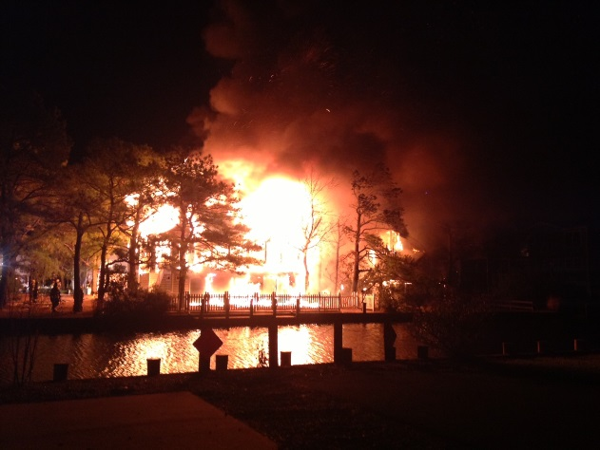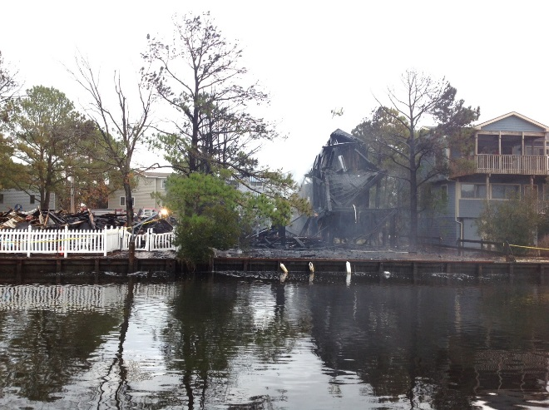

I contacted both home owners and expressed my sympathy with their losses.

A news update informed property owners that a building permit would not be required for the demolition, removal, and replacement of flood damaged items and materials. Any construction exceeding the limits of the flood damage or other items and materials that were not damaged by flood water requires a building permit from Sussex County and the Town of South Bethany. Again, property owners were instructed to use flood damage resistant materials and to only use contractors with mercantile licenses. They were also instructed to call the Code Enforcement Constable or the Town Manager if they had questions.
We are still concerned that home owners are not checking on their houses. I again implored them to come as soon as possible or assign someone to check on their houses. I emphasized that it is important for the health and safety of homeowners, their property, visitors and surrounding neighbors. Mold and mildew grows and spreads very quickly and within the walls, thus not necessarily visible. In addition, there is no way for the Town or neighbors to determine the extent of other damage from the outside of the house. How do you make people check their homes?

Friday, November 16, 2012
The Town will conduct one more curbside pickup of storm-related debris on Monday. However, the dumpsters have been so “popular,” we will leave them at the Town Hall until the end of November.

MOVING ON
There are still a great deal of questions and issues related to insurance coverage and questions about the house fires. I shared a note from one our home owners:
"Our electrician found in our old house (1957) some old wiring under our house in the flooded crawl space that was not properly insulated and there was evidence of sparking within the wires. In fact, he said that it caused some of the water next to it to boil but it didn't start a fire because it was submerged in the water of our crawl space. He showed us the bare wires and junction boxes that were submerged in the water. He further said that he is fearful that if other homes are wired similarly they might be accidents waiting to happen. Those people with older homes or even new ones could be vulnerable if there is any chance that their wiring/insulation got wet. Those owners should be aware that they need to have their electrician inspect their houses sooner rather than later."
In early December, after the holiday lights had been up for some time, they started blowing out. We realized they had also been victims of the flooding. I used this opportunity to again emphasize how important it is to check out your house.
On January 7, Senator Carper and the Small business Administration held a small press event at the Town Hall to help spread the word that the US Small Business Administration announced that Sussex County homeowners adversely affected by Super Storm Sandy could apply for special SBA loans. However, secondary homes were not eligible, therefore, eliminating most of our property owners.
In June the Sea Level Rise and Storm Surge Committee was formed to proactively work towards protecting South Bethany against future damages from canal flooding. One such change to our ordinances could be the building of higher foundations and raising the roof limits to still accommodate three-story homes.
I pray that we will not experience any storms like this in the near future. We can only educate people in preparing for these storms by not storing items below the 100-year flood level and using water resistant materials at ground level.
It was such a relief to know we suffered no human injuries or deaths in this storm; one family lost their beloved pet dog and our dog Coco Chanel lost her leg due to an infection from the waters. We pray for those in New Jersey and New York who suffered more losses.

